3. Graphs and Traversal
Aim:
Traversal of Graph using Breadth-first Search and Depth-first Search Techniques.

Theory:

1. Graphs
A graph is a data structure that contains a set of nodes or vertices, represented by V, and a set of interconnecting edges between pairs of vertices, represented by E. Formally, any graph G can be represented as:
G = { V, E }
A vertex or node in a graph is represented as a labelled circle. Edge represents a path between two vertices.
Two vertices or nodes are said to be adjacent in a graph, if they are connected to each other through an edge.
This means to say that two nodes i and j are adjacent if:

A path represents a sequence of edges between two vertices.

For example, in the above figure:
V = { A, B, C, D, E }
E = { (A,B), (A,C), (A,D), (B,A), (B,D), (B,E),...}
Since, (A,B) belongs to E, we can say that B is adjacent from A.
ABE is that path from node A to node E.

2. Representation of Graphs
A. Adjacency List
The adjacency-list representation of a graph G = (V,E) consists of an array Adj of |V| lists, one for each vertex in V. For each vertex, the adjacency list Adj[u] contains all the vertices v such that there is an edge . That is, Adj[u] consists of all the vertices adjacent to u in G.
If G is a directed graph, the sum of the lengths of all the adjacency lists is |E|, since an edge of the form (u,v) is represented by having v appear in Adj[u]. If G is an undirected graph, the sum of the lengths of all the adjacency lists is 2|E|, since if (u,v) is an undirected edge, then u appears in v’s adjacency list and vice versa.
B. Adjacency Matrix
For the adjacency-matrix representation of a graph G = (V,E), we assume that the vertices are numbered 1,2,...,|V| in some arbitrary manner. Then the adjacency-matrix representation of a graph G consists of a |V| X |V| matrix
A = (a_{ij}) such that
(a_{ij}) = 1 if
(a_{ij}) = 0 otherwise

Since in an undirected graph, (u,v) and (v,u) represent the same edge, the adjacency matrix A of an undirected graph is its own transpose: A = A^{T}.
In some applications, it pays to store only the entries on and above the diagonal of the adjacency matrix, thereby cutting the memory needed to store the graph almost in half.

3. Graph Traversal Techniques
A. Breadth-first Search
Given a graph G = (V,E) and a distinguished source vertex s, breadth-first search systematically explores the edges of G to “discover” every vertex that is reachable from s. It computes the distance (smallest number of edges) from s to each reachable vertex. It also produces a “breadth-first tree” with root s that contains all reachable vertices. For any vertex v reachable from s, the simple path in the breadth-first tree from s to v corresponds to a “shortest path” from s to v in G, that is, a path containing the smallest number of edges. The algorithm works on both directed and undirected graphs.

Breadth-first search always discovers all vertices at distance k from s, before discovering any vertex that is at a distance k+1.
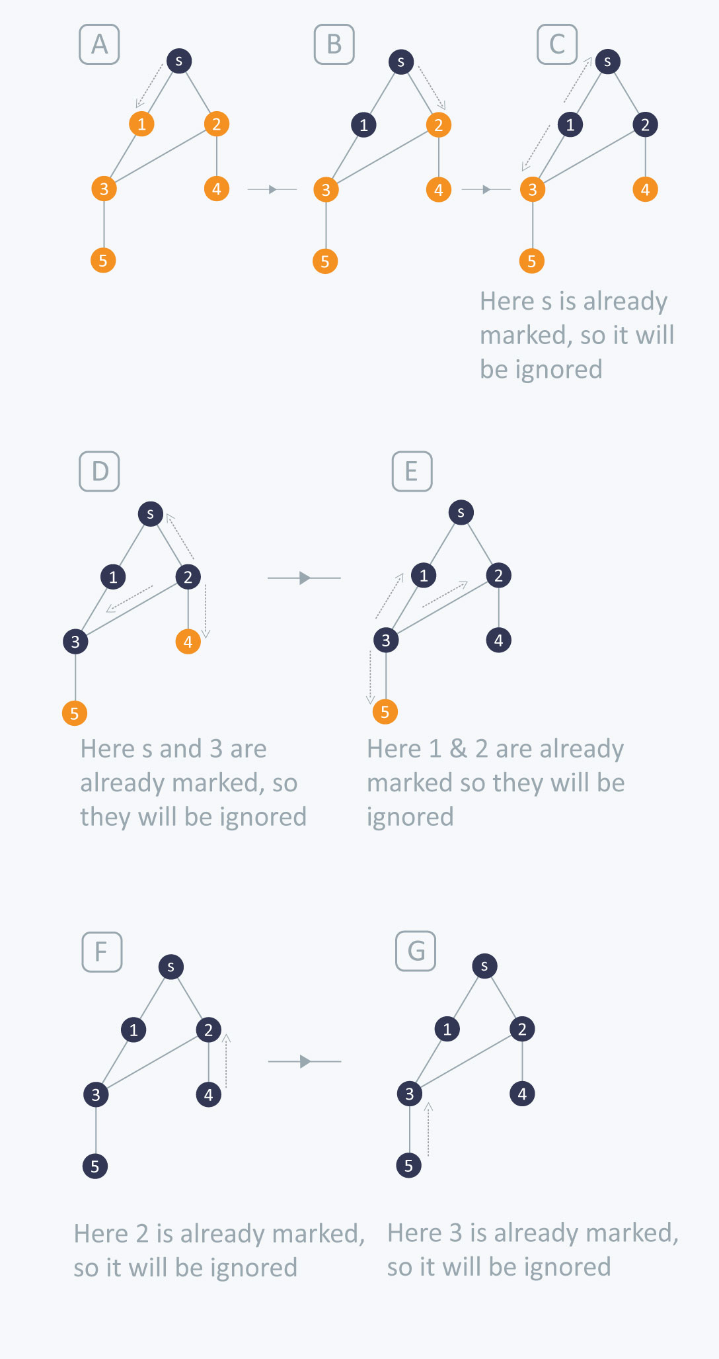
Fig 1. Example of traversing a graph using BFS technique
B. Depth-first Search
The strategy followed by depth-first search is, as its name implies, to search “deeper” in the graph whenever possible. Depth-first search explores edges out of the most recently discovered vertex v that still has unexplored edges leaving it. Once all of v’s edges have been explored, the search “backtracks” to explore edges leaving the vertex from which v was discovered. This process continues until we have discovered all the vertices that are reachable from the original source vertex. If any undiscovered vertices remain, then depth-first search selects one of them as a new source, and it repeats the search from that source. The algorithm repeats this entire process until it has discovered every vertex.
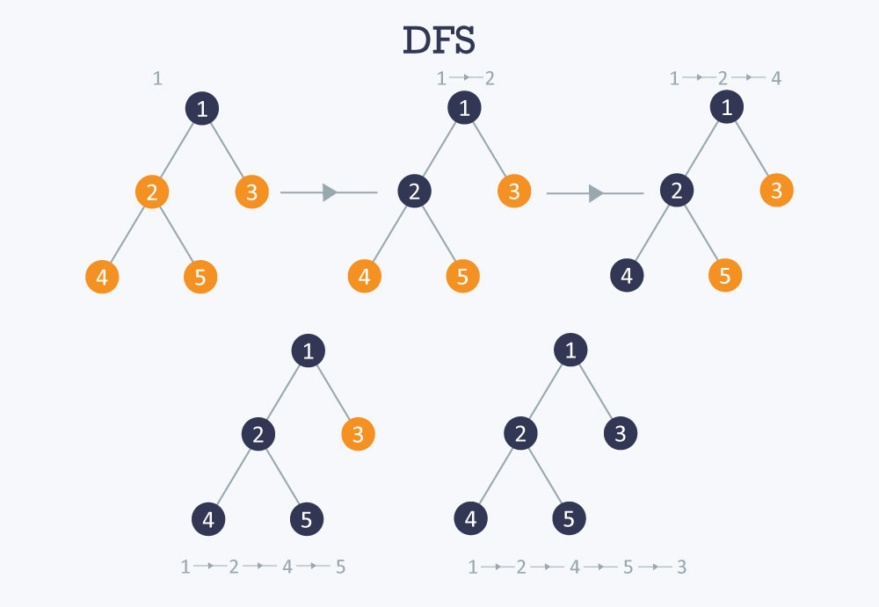
Fig 2. Example of traversing a graph using DFS technique

Implementation:

A. Breadth-first search
#include<stdio.h>
#include<stdlib.h>
#include<unistd.h>

struct Node{
int val;
struct Node* next;
};

void printList(struct Node *first);

void main() {
int m, n, i, j, k, head_nodes, prev, x, p, q, r, count, from, to;
int visited[20]={0},queue[20]={0},front=0,rear=0,new_val,num,next_node;
int bfs[20]={-1};
int counter = 0, element = 0, current = 0;

count=0;
struct Node *head[20],*temp,*dest,*new[20],*bidirect[20],*start;

temp = (struct Node*)malloc(sizeof(struct Node));
dest = (struct Node*)malloc(sizeof(struct Node));
start = (struct Node*)malloc(sizeof(struct Node));

//Input the number of vertices and edges
printf("Enter number of vertices and edges");
scanf("%d%d",&m,&n);
for (i=0;i<m;i++)
{
head[i] = (struct Node*)malloc(sizeof(struct Node));
head[i]->val = i;
head[i]->next=NULL;
}

//Input the edges
printf(" -------- Enter edge data ---------\n");
for (i=0;i<n;i++)
{
printf("Enter data for edge %d:",i);
scanf("%d%d",&from,&to);
//Creating the adjacency list for source node
new[i] = (struct Node*)malloc(sizeof(struct Node));
new[i]->val=to;
new[i]->next=NULL;
//Enter edge from source to destination
if (head[from]->next == NULL)
{
head[from]->next = new[i];
}
else{
temp=head[from];
while(temp->next != NULL)
{
temp=temp->next;
}
temp->next=new[i];
}
//Creating adjacency list from destination to source
bidirect[i] = (struct Node*)malloc(sizeof(struct Node));
bidirect[i]->val=from;
bidirect[i]->next=NULL;
//Enter edge for destination to source
if (head[to]->next == NULL)
{
head[to]->next = bidirect[i];
}
else{
temp=head[to];
while(temp->next != NULL)
{
temp=temp->next;
}
temp->next=bidirect[i];
}
}

//Test adjacency list
for (i=0;i<m;i++) {
printList(head[i]);
}

front = 0;
rear = 0;

//Input start node, enqueue it and mark it as visited
printf("\nEnter starting node");
scanf("%d",&num);
visited[num] = 1;
queue[rear]=num;
rear++;

//Traverse the graph
while(front != rear) {
printf("\nQueue is not empty");
//Step 1 : Dequeue
element = queue[front];
front++;
//Step 2 : Add popped element to the traversal result
printf("\nPushing current node %d into result",element);
bfs[counter]=element;
counter++;
printf("\n%d elements traversed",counter);
//Step 3 : Enqueue neighbours of element
//3.1 --> if node has an empty adjacency list, exit program because node is isolated
if(head[element]->next == NULL) {
printf("\n%d is an isolated node\n",element);
exit(0);
}
//3.2 --> if node has a non-empty adjacency list, add its neighbours into the queue
else {
temp=head[element]->next;
printf("\nTrying to add neighbours of %d node",element);
while(temp != NULL) {
current=temp->val;
if(visited[current] == 0) {
printf("\n%d node has NOT BEEN VISITED, inserting into queue",current);
queue[rear]=current;
rear++;
visited[current] = 1;
printf("\nFRONT --> %d; REAR --> %d",front,rear);
} else {
printf("\n%d node has ALREADY BEEN VISITED",current);
}
temp = temp->next;
}
}
}
printf("\nQueue is empty");

//Print result of BFS
printf("\n------------------BFS-------------------------\n");
i=0;
while(i < counter) {
printf("%d\t",bfs[i]);
i++;
}
}

/* Function to traverse a given Circular linked list and print nodes */
void printList(struct Node *head)
{
while (head != NULL)
{
printf("%d --> ", head->val);
head = head->next;
}
printf("\n");
}

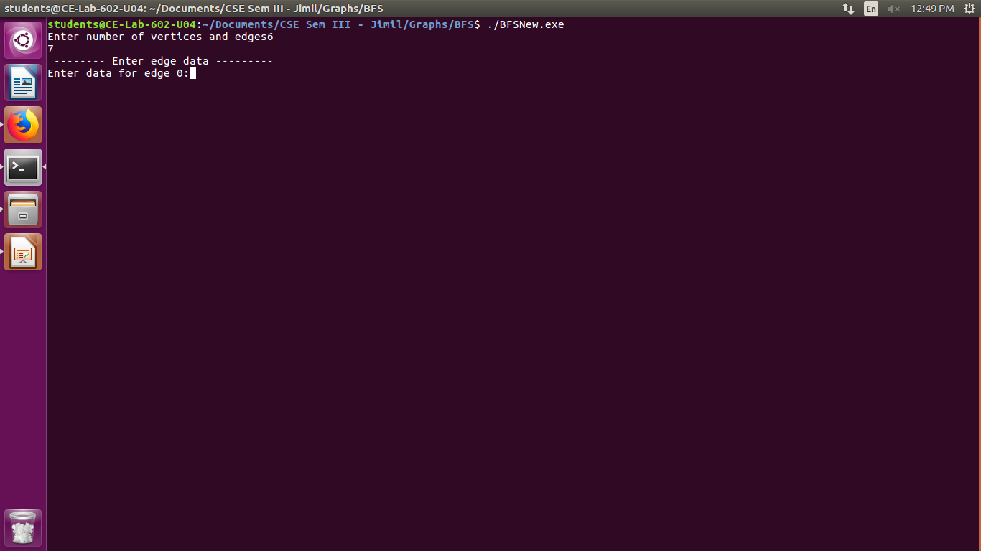
Output:

Fig 3.1. Enter the number of vertices and edges
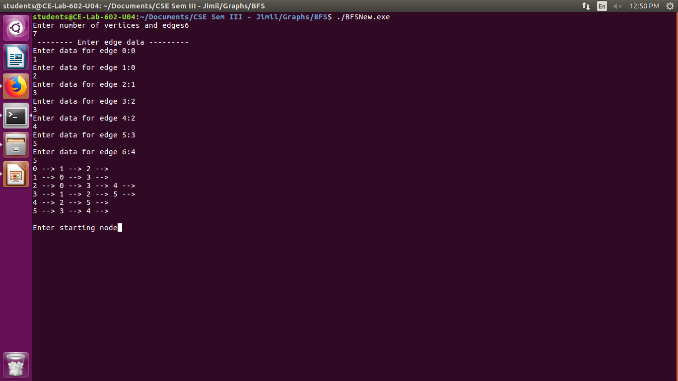
Fig 3.2. Enter data for all the edges in the graph and form the adjacency list
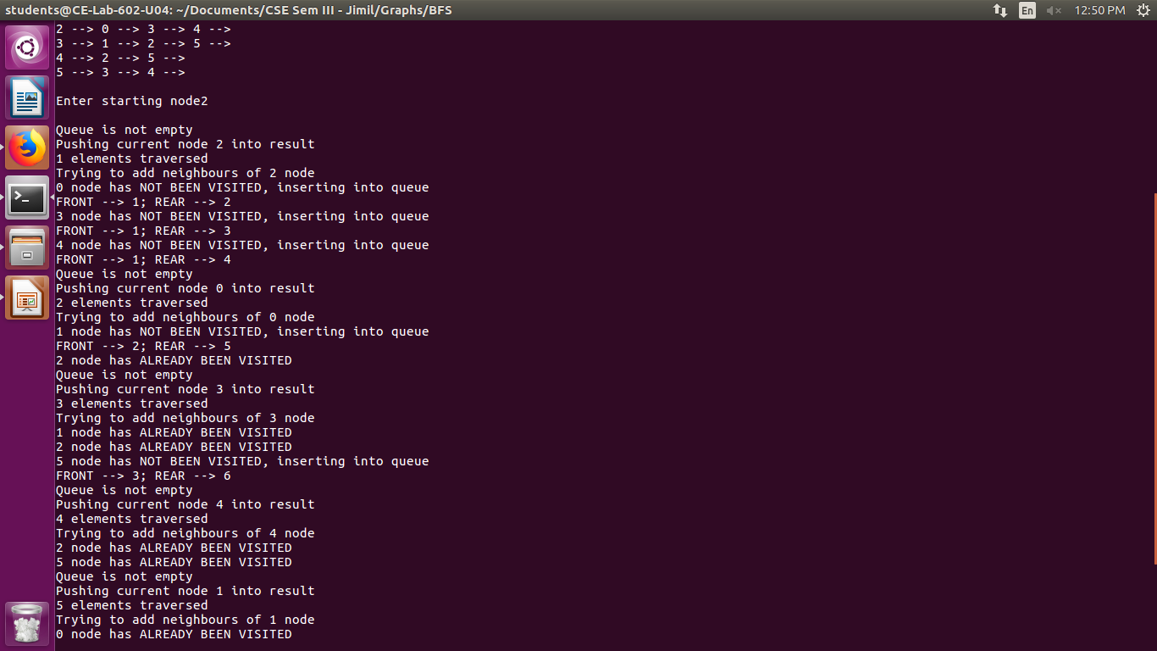
Fig 3.3. Enter source vertex for the BFS algorithm
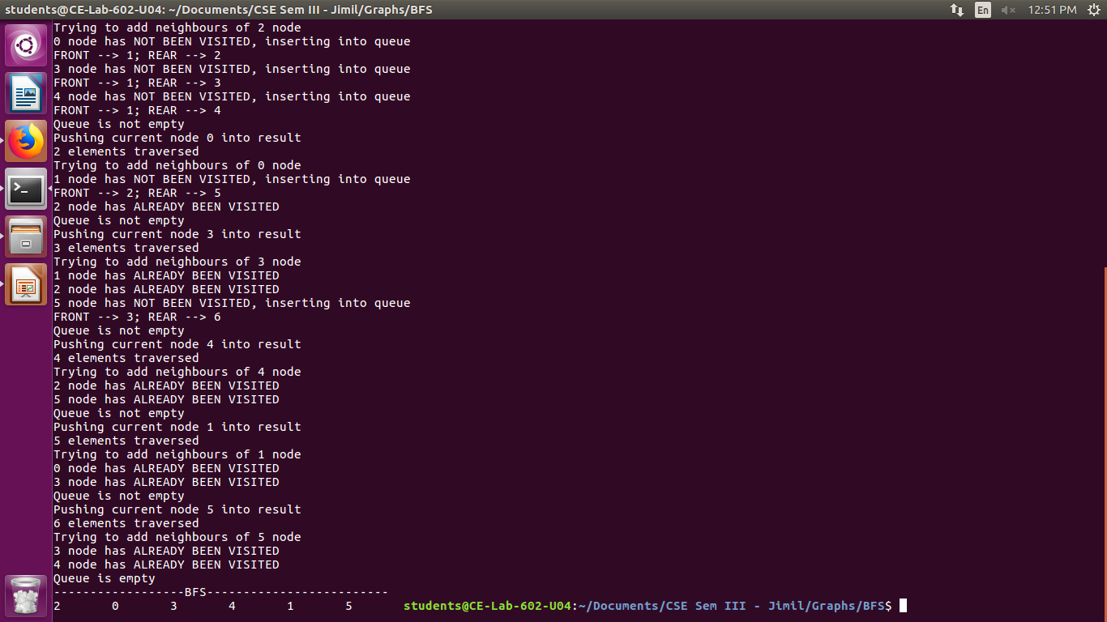
Fig 3..4. Vertices traversed from the source node in BFS fashion

B. Depth-first Search
#include<stdio.h>
#include<stdlib.h>
#include<unistd.h>
struct Node{
int val;
struct Node* next;
};
// Function to traverse a given Circular linked list and print nodes
void printList(struct Node *head)
{
while (head != NULL)
{
printf("%d --> ", head->val);
head = head->next;
}
printf("\n");
}
//Util function to print stack
void printstack(int stack[], int top) {
int i;
for(i = 1; i <= top; i++) {
printf("%d\t",stack[i]);
}
}

void main() {
int m,n,i,head_nodes,from,to,visited[20]={0},top=-1,start,element=0;
int dfs[20]={-1};

struct Node *head[20],*temp,*new[20],*bidirect[20];
struct Node *dest, *source;

temp = (struct Node*)malloc(sizeof(struct Node));
dest = (struct Node*)malloc(sizeof(struct Node));
source = (struct Node*)malloc(sizeof(struct Node));

printf("Enter number of vertices and edges");
scanf("%d%d",&m,&n);
for (i=0;i<m;i++)
{
head[i] = (struct Node*)malloc(sizeof(struct Node));
head[i]->val = i;
head[i]->next=NULL;
}
printf(" -------- Enter edge data ---------\n");
for (i=0;i<n;i++)
{
printf("Enter data for edge %d:",i);
scanf("%d%d",&from,&to);
new[i] = (struct Node*)malloc(sizeof(struct Node));
new[i]->val=to;
new[i]->next=NULL;
if (head[from]->next == NULL)
{
head[from]->next = new[i];
}
else{
temp=head[from];
while(temp->next != NULL)
{
temp=temp->next;
}
temp->next=new[i];
}
//Creating adjacency list from destination to source
bidirect[i] = (struct Node*)malloc(sizeof(struct Node));
bidirect[i]->val=from;
bidirect[i]->next=NULL;
//Enter edge for destination to source
if (head[to]->next == NULL)
{
head[to]->next = bidirect[i];
}
else{
temp=head[to];
while(temp->next != NULL)
{
temp=temp->next;
}
temp->next=bidirect[i];
}
}
for (i=0;i<m;i++) {
printList(head[i]);
}
top=0;
printf("\nEnter the starting node");
scanf("%d",&start);
top++;
dfs[top] = start;
visited[start] = 1;
while(top != 0) {
//Pop the top node on the stack
element = dfs[top];
top--;
printf("\nVisited %d node",element);
//Traverse it's adjacency list
temp=head[element]->next;
while(temp != NULL) {
if(visited[temp->val] == 0) {
printf("\nAdding %d node onto stack",temp->val);
top++;
dfs[top] = temp->val;
visited[temp->val] = 1;
//Print the stack
printf("\n---------------STACK---------------\n");
printstack(dfs, top);
}
temp = temp->next;
}
}
printf("\n");
}

Output:
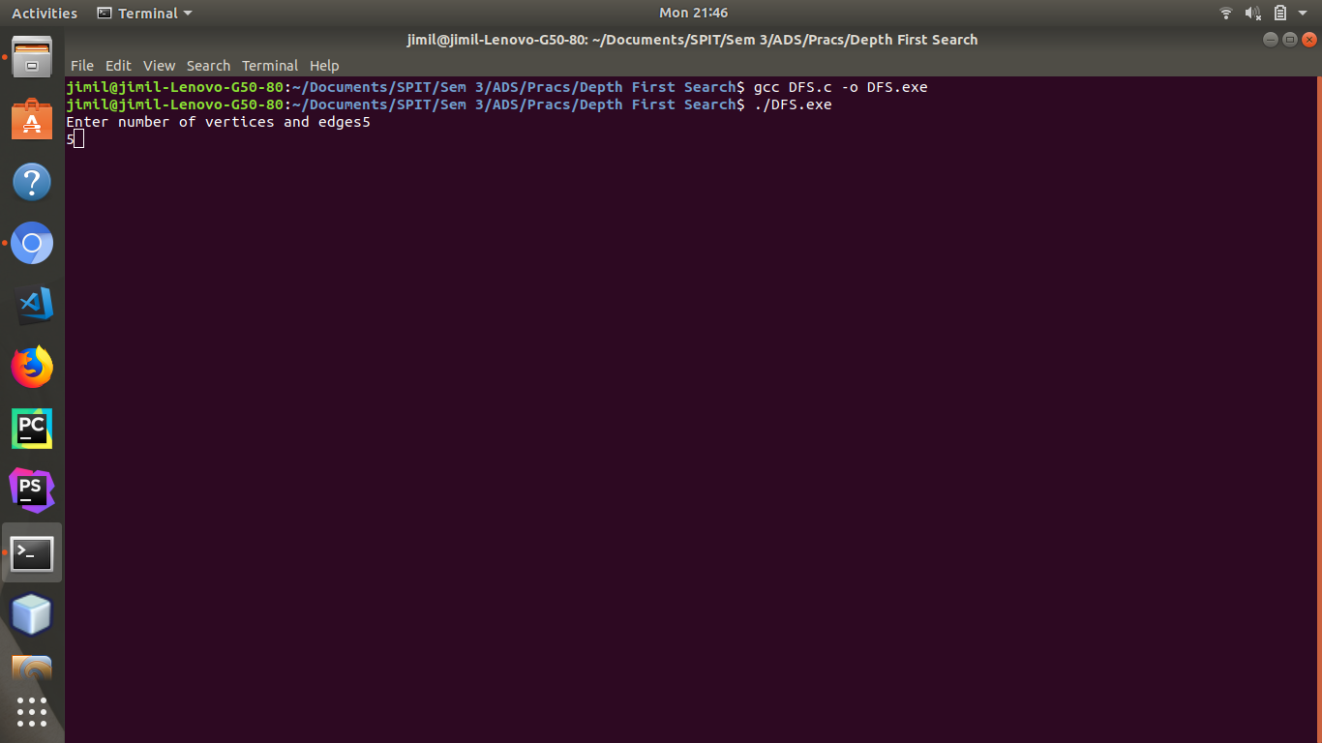
Fig 4.1. Enter number of vertices and edges
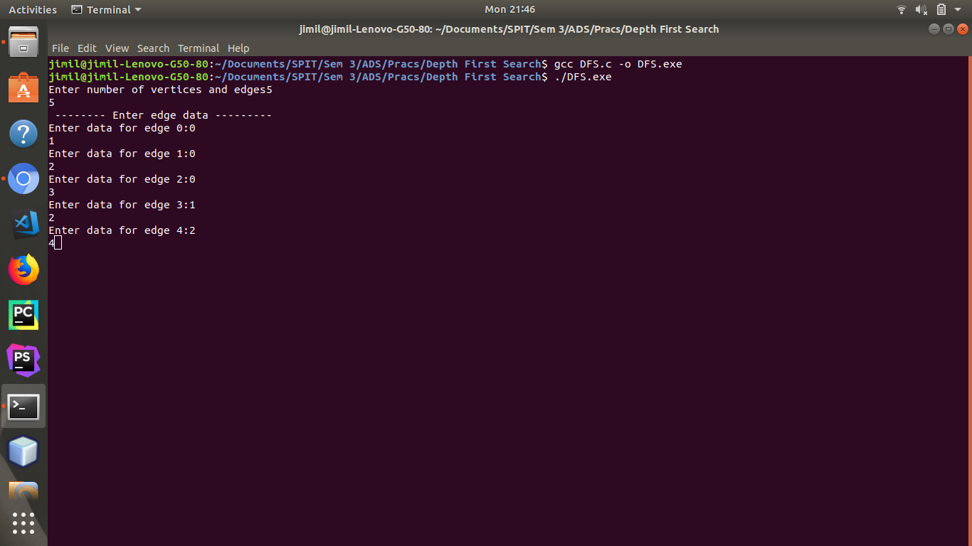
Fig 4.2. Enter data about all edges in the graph

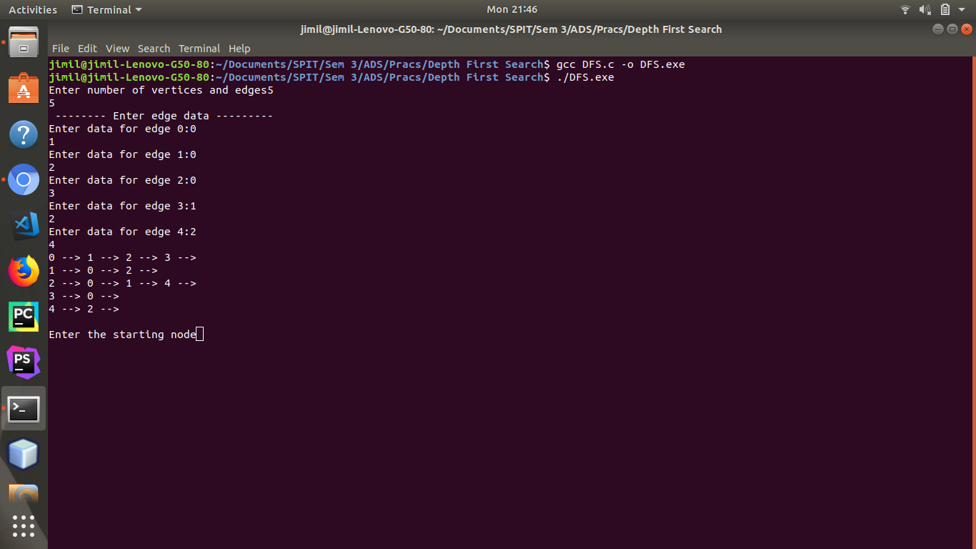
Fig 4.3. Form Adjacency List and get source vertex from user
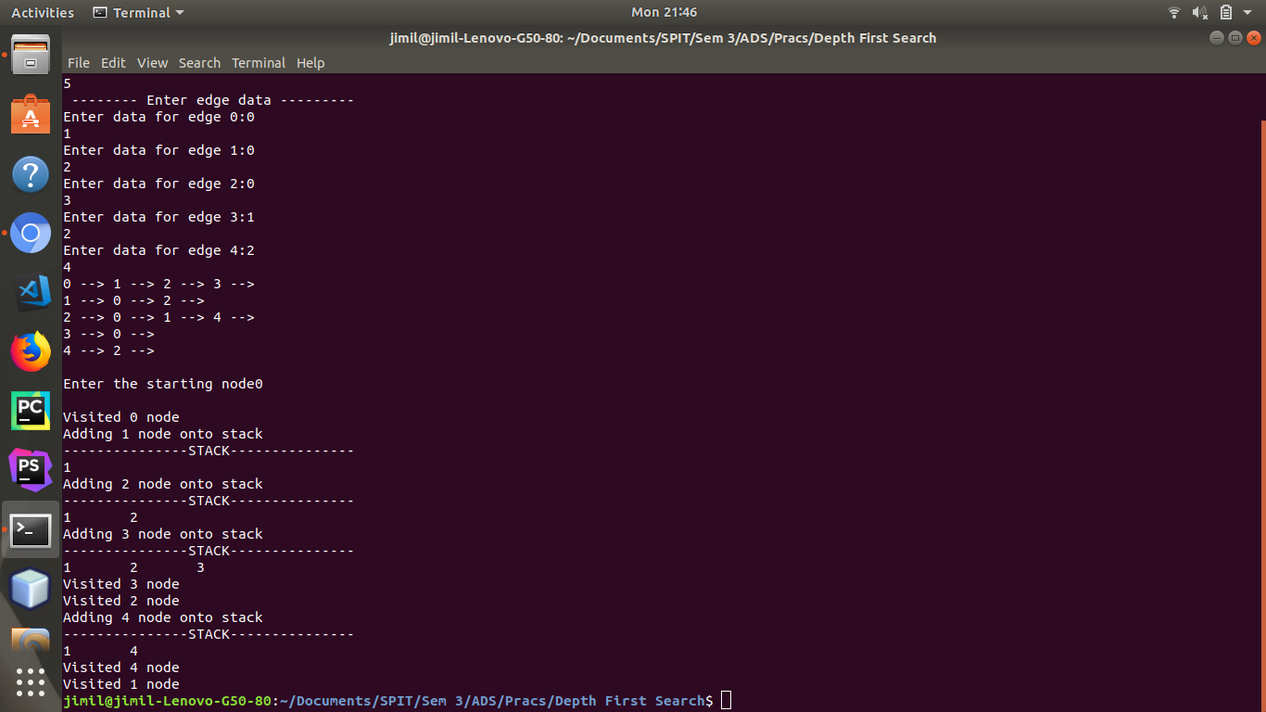
Fig 4.4. Vertices traversed and pushed and popped into stack from source vertex, using DFS technique

Result:
By creating a graph and representing it as an adjacency list, we were able to traverse the graph using Breadth-first Search and Depth-first Search techniques.
It was observed that the Breadth-first Search technique discovered all nodes at distance ‘k’ from the source vertex ‘s’, before discovering any node that was at a distance ‘k+1’.
In case of Depth-first Search, it traversed till the end of a path, and then backtraced along the same path until it found a previously unexplored path.

Conclusion:
Thus, in this experiment, we have created graphs and traversed them using Breadth-first search and Depth-first search techniques.

